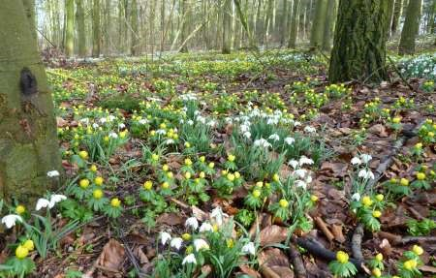

The Newsletter for Middleton on the Wolds

Issue No 23

F
EBRUARY
2021

NEXT COPY DATE
14th February

Please send in your contributions to middletonflyer@yahoo.com by the end of the copy day. If I don’t acknowledge them please get in touch to make sure they have arrived.

Lyn
4 The Paddocks 219500

CORRECTION

My sincere apologies for making a spelling error in the heading of Mave
Prouse’s obituary in November’s edition of the Messenger. I have know Mave for many years, she was very friendly to me when we came to the village and she will be very much missed by lots of people here in Middleton.

editorial
Christmas has been and gone and wasn’t it great to see so many houses lit up? The competition can certainly help give the village a festive feel. We also had a carol service on the village green. I hope both events can become regular parts of village life as they both help instil a sense of community. And then there was New Year. Did yours come in with a bang or a whimper?
Ours was certainly less lively than usual (and with a
lot less dancing!) but we still had a good time. We decided that we would enjoy what we had rather than worry about what we were missing. It’s that whole thing about being flexible; we can’t do that for the present but we can do this instead so we might as well have fun doing it.
Which brings me (‘again!’ I hear you cry) to COVID 19. Although we are in another lockdown right now we are also rolling out the vaccination programme as quickly as is practicable so we can at least see light at the end of the tunnel. In the meantime, it is up to each of us to abide by the current guidelines to try and slow down the rate of infection. I don’t know if they will work but I haven’t seen any virologists saying otherwise. Mind you, I don’t read conspiracy theories on Facebook so I may be missing out! I think the real point here is that, even though we find the measures at least inconvenient, we aren’t just following them for our own benefit but, more importantly, we do it because it helps everybody else. And while we’re thinking of others keep an eye out for your neighbours. Not everyone may be coping as well as you so be ready to help out if there is a need.
Andrew and Peter have done wonders on the embankment planting I don’t know how many trees (and there are more to go, apparently) and keeping it tidy. It’s all helping to give us pleasant places to walk right on our doorstep. And that’s not just for lockdown but for ever. With this and with the amended plans for the new play area we are certainly doing our bit for the environment.
Look at that, I’ve got to the end and no mention of Brexit!
Stay safe.
Cheers,

Mike

If you have any ideas, comments or complaints (especially complaints) you want to share then send an email to middletonflyer@yahoo.com.
Remember, we can’t respond unless we receive your message.

St Andrew’S church

There will be no services at St. Andrews for the foreseeable future except for funerals, arranged with Rev`d Jane Anderson, and pre-booked private prayer.

ELECTORAL ROLL

Every six years each parish in the Church of England renews its Electoral Roll; that means that all the names are erased from the present roll. Those already on have to reapply for their names to be included on Electoral Roll.

The Church of England Electoral Roll is a list, by name and address, of the active faithful members of the church, which each parish is required to set up under the Church Representation Rules; this is a legal requirement.

The Roll is used to determine eligibility for attendance and participation at the Annual Parochial Church Meeting (APCM) and for election to the Parochial Church Council (PCC).

If you would like to become a member of the PCC Electoral Roll, please contact the following for an application form by no later than Friday 26th February 2021.

Mrs Margaret Woolston
Phone: 217699
Email: tremar@tmwoolston25.plus.com

QUIZ PAGE
- I am the egg man? is a line from which song by The Beatles?
Which musical's lead male character ends many sentences
- with "et cetera, et cetera,
- When was the Euro introduced as legal currency on the world market?
- In UK pre-decimal coinage, how many farthings were in one penny?
- Which V is a colour, and a girl’s name?
- How old was Winston Churchill when he died?
- Which dessert is also known as ‘Tuscan Trifle’?
Double Dutch, Double Unders and Dipsy Doodles are all terms used in which
- activity?
- Texting the abbreviation RBTL means what?
- What is the most popular cheese to be produced and consumed in Greece?
Quiz set by Rowland Wooldridge
VALENTINE DINGBATS SUDOKU
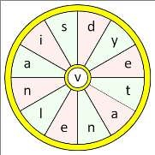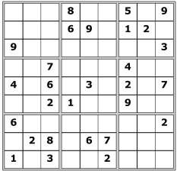
All answers on page
20

WORD WHEEL

This topical themed word wheel is
made from
2
words
. Try and find
these words, then make as many
words of any length as you can from
these letters. You can only use each
letter once, and each word must
include the letter

V
.

LOCAL HISTORY
SCHOOL DURING THE FIRST
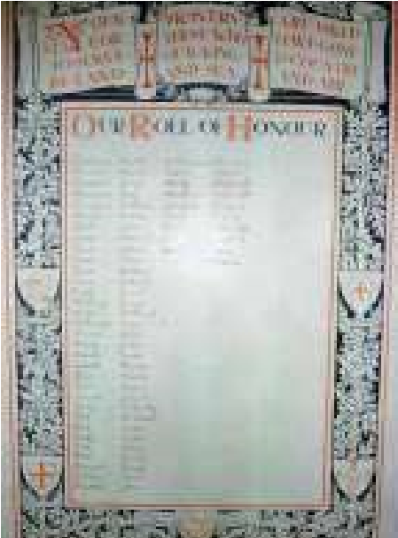
WORLD WAR
When the school resumed after the summer holidays in that fateful year any mood of optimism had vanished. War had been declared on the 4th August and typhoid was raging in the village. The conflict dealt a blow to the school’s progress in that the children’s education was to a certain extent subservient to the needs of agriculture which had itself gone into a slow decline since the 1870s resulting in an over dependence on imports which if curtailed could bring a threat of starvation. Home production had to be increased so more children were released for farmwork under the Conditional Leaving Certificate Scheme which enabled them to leave school prematurely if they achieved certain grades.
In the intense patriotic atmosphere teaching staff came under pressure for military service particularly after the German Navy’s bombardment of the North Sea Coast Towns in December 1914. Ernest Parkinson, an assistant teacher, enlisted and Arthur Jordan, the headmaster, volunteered but because of medical problems only served as a special constable while Frank Loftus a former teacher was killed in action in 1917.
Collections of money were made for the war effort and in 1915 a Roll of Honour Board was purchased and subsequently unveiled in 1916. In May of that year the tercentenary of Shakespeare’s death was marked with songs, poems and models. No doubt the heroic nature of some of the Bard’s output resonated with the spirit of the times.
More cheeringly the County Council awarded the village’s first open scholarships to Edwin Jordan, the headmaster’s son and Marion Baxter. Another first was the landing of an aeroplane in a nearby field, possibly the one used for school horticulture, prompting Mr Jordan to close the school early to allow the pupils to inspect it. Meanwhile the growing awareness of the spread of disease was apparent when the school had a one week crusade against flies, killing 5000 thousand in the process.
The school suffered from staff shortages during the war and in July 1918 the headmaster reported that “Spanish Influenza” had affected attendance and later the Local Education Authority ordered the school by telegram to close until the 2nd of December, something which will strike a chord with the villagers of Middleton in the year 2021. The news of the Armistice signing was heard at the school at ten past one on the 11th November followed by a half day holiday.
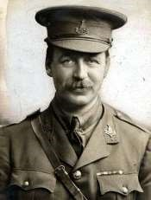
The war had had a profound effect on the school, village and country at large and at the end of January 1919 the headmaster was reporting that the influenza epidemic had adversely affected the mental as well as the physical health of many scholars. A famous local fatality at the early age of 39 was Sir Mark Sykes of Sledmere, M.P for Hull Central, County Councillor, diplomat and founder of The Wolds Reserve, who had visited the school in 1909 on Empire Day and who was present at the Versailles Peace Conference. Described as an effervescent personality, he was an advisor to the British Government on the
future structure of the states to be created after _{Sir Mark Sykes} the fall of the Ottoman Empire.
In 1918 the Fisher Education Act raised the school leaving age from 12 to 14, introduced welfare provisions and put teachers’ salaries on a national basis. However the Act’s good intentions were seriously thwarted by the dire financial situation in the 1920s and 30s so that the full benefits were not felt until after the Second World War.
Geoff Wisher

Heating oil
The introduction of another lockdown in the United Kingdom has triggered a rise in the price of domestic heating oil, at a time when we all are effectively house bound.
Some oil companies treat their customers in the same way that car insurance companies do, they do not always give you the best price. Remember that they do keep records of when and how much you last paid, and how regularly you require oil.
Like car insurance it is worth looking for a competitive price now and again, you can save anywhere between one and ten pence per litre (1.05 – 10.5p/l after vat) if you are prepared to shop around occasionally. That is between £5:05 and £52:50 on 500 litres of kerosine.
Below is a list of companies in this area and the prices I have been quoted recently.
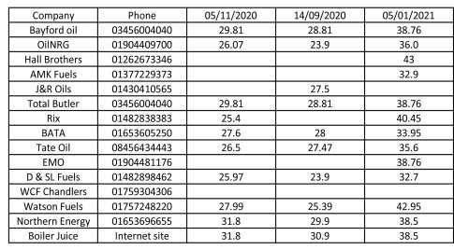
I am not recommending any one company, I am just showing the range of prices that are being quoted.
I also recognise that some people pay by standing order or direct debit to smooth out the payments, and give them security of supply. It is still worth looking at the above table with a view to change to a company that consistently gives a lower price than your current supplier.

Chris Atkin

Old railway line renovation

New Year Update
A great many residents have taken the opportunity to walk along the old railway embankment in 2020. This can be a little muddy at times, but still provides an enjoyable woodland walk right on our doorstep.
A few of us worked throughout the summer removing the invasive dog rose which inhibited ground feeding birds from searching the undergrowth. There were days in the autumn, when it was positively uplifting as the sun was shining through the branches and the plentiful red hawthorn berries allowed birds to gorge themselves on this feast.
Since early October we have been planting young under-storey trees in the spaces created by the removal of the dog rose and the damage caused by February’s tree surgeons. We have planted almost 200 new native trees; including hawthorn, rowan, hazel, apple, cherry, birch, viburnum, spindleberry and field maple. All will, if successful, provide blossom and berries for insects, bats and birds.
We have had ‘donations’ from residents of holly and buddleia and three residents responded to my request for spent grow bags. This was mixed with the planting medium from the tree nursery to ensure every new tree received some moisture retentive material – vital when you realise that the ‘soil’ on the embankment is ash/clinker waste from the steel industry. Every new young tree has been given a green sleeve to protect it from rabbits and the wind, whilst it establishes some roots. These will all be removed once it looks like the trees can survive without them.
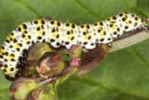
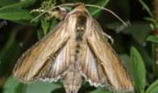
I would like to offer my heartfelt thank you to another lovely neighbour who offered a sum of money to support the cost - the trees are funded from my own willing pocket. The Parish Council received two deliveries of ‘whips’ of native trees from the Woodland Trust. These have been potted up to be grown on before being used this autumn or even autumn 2022.
Mullein
caterpillar
and moth

Another neighbour has offered to knock up some bird boxes for us to install in February. We have been given several great mullein plants (much favoured by rabbits), to hopefully attract the mullein moth and honeysuckle has been planted to encourage the elephant moth. This feeds on the nectar of the flower but lays its eggs on the rosebay willow herb, of which we have a good clump.
I have spoken to a lot of residents who have passed as we’ve worked on the embankment. People like the idea of a community woodland and this is something we should try to develop.
I would like to form a Middleton Green Volunteers group in 2021. This will have to wait until it is safe to meet up in groups again Elephant Hawk Moth once we are safe from the covid virus.
If you think you would be interested in the Middleton Green Volunteers then feel free to share your details with myself (Andrew Naylor) on 07825 882972. I will then contact you once covid allows!
Stay Safe
Andrew Naylor

Village hall news
We are very grateful to have received a legacy from Regina Bradley who lived in Greenfield Road and will be putting most of the money towards internal improvements (more details later). We will also be buying a bench seat for the front of the hall for the use of villagers on their walks around the village.

The Village Hall Committee

Middleton on the wolds ce ve school
Executive Headteacher: Mrs E Harros
Station Road, Middleton on the Wolds, Driffield YO25 9UQ
E-mail:middleton.primary@eastriding.gov.uk Tel: 01377 217323

Middleton Minis
Following Government guidance, Middleton Minis will not be running for the near future. Once we are allowed to re-open will inform you via the parish newsletters.

On-going Collections
On-going Collections – We collect used stamps and used batteries. Please note we are not currently collecting used printer cartridges or mobile phones until we can source a new company to collect and recycle them. Thank you.

Middleton on the Wolds Nursery
At Middleton on the Wolds CE (VC) Primary School  Providing education for 2, 3 and 4 year olds Monday - Friday.
 We accept the Government’s childcare vouchers for up to 30 hours of free provision for 3 year olds (conditions apply)
 Additional sessions can be purchased for £13.50 per session for 3 year olds and £15.75 for 2 year olds.
 Lunchtime sessions are £1.75 (free if children attend for the whole day) with the option to purchase a school meal for £2.40.
 Children are welcome in the term after their 3rd birthday for funded places.
For further details please contact: Sharon Stone
Email: middleton.primary@eastriding.gov.uk Tel: 01377 217323

School Dates
We break up for Half Term on Friday 12th February and return to school on Monday 22nd February.

All staff and pupils at Middleton School wish you all
a Happy New Year.

Local Birds & wildlife
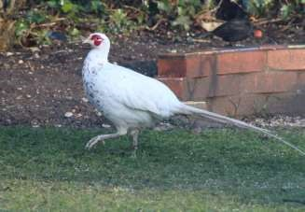

Photo by Tina Walker

Happy New Year! (If at all possible…)
After the last Messenger deadline there seemed to be a flurry of activity. At the end of November there were still geese coming over in large numbers, seen by Sheila over Middleton and Judy over Kirkburn. At dusk one day I wrapped up well and sat out in the garden, waiting for them to fly back to the Humber after feeding on the Wolds. I can only think that they flew back over North Dalton, landed on Station Road by the school and tiptoed down the road until they were safely past Greenfield Road when they took off again, secure in the knowledge that they had avoided being mentioned in the Messenger!
Sheila also had a memorable afternoon outing just outside the village when she saw 5 red kites, 3 buzzards, 5 kestrels and a flock of linnets! Hazel saw a treecreeper at the end of the embankment – she had never seen one in Middleton before. Another first – she was walking along the embankment towards the playing fields “When this little head popped up from the left side, a very small young stoat! I have never seen one on the embankment before – it made my day!”
Stella also had an exciting moment when driving back from Beverley, nearly at Lund (this is still last year, before the present lockdown) “Standing at the base of the hedge was what looked very like a kingfisher, but I couldn’t really believe it. There was traffic behind but I turned round at Lund and there was nothing there. Very odd.” I’m sure it must have been one though, because there is nothing else like them – and on holiday in Norfolk I saw one flying away from me over an open field, so they don’t stay next to water the whole time.
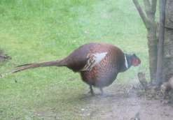
Moving on to 2021, pheasants are putting together a strong case for being Bird of the Year. There is a white pheasant up on The Paddocks, seen – and photographed – by Lyn and Tina. It itsn’t an albino – there are dark speckles on the feathers, red on it’s head and it doesn’t have pink eyes, so the word for it is leucistic – it can apply to animals and reptiles, as well as birds and means that some of Photo by Ian Lavender the normal identifying colours are replaced with white.
Meanwhile there is something of a soap opera going on in our back garden. We have had a peaceful self-effacing male pheasant visiting for some time and to his obvious shock he was joined by a female this week. She pecked around and took absolutely no notice of him, while he ruffled his feathers and then fluffed himself up to his maximum size, and his little “ears” pricked up. He stalked around her, looking very impressive, and then to his horror she was joined by three more females. Who were equally unimpressed. It would be nice if we were to have the patter of tiny pheasant feet around our garden, but I think he will have to wait until the spring has sprung a bit more and they feel in a more frivolous frame of mind. Or February 14th ?
Please let me know what is going on in your gardens and what you see on your walks – and and it is always lovely to get photos – we will publish what we can.
Stay safe,
Barbara
Lavenderbarbara97@gmail.com or text 0777 192 7868

Parish council
Hi Everyone. You may remember that back in November we asked you to fill in a short survey to tell us your views on an improved play area the Parish Council are considering at the Recreation Club. We wanted to share with you some of the feedback and comments from the survey, which will help shape our plans and provide something that we hope the majority of the village can be proud of.
Sixty-six of the surveys were collected, representing around 16.5% of the households in the village. This response was lower that we'd hoped, but still provided enough information for us to work from. It was good to see that most people said the Orchard Drive play area, designed for the under 10 year olds is well used, with 60% saying it was used Often or Sometimes compared to just 16% that responded as Never.
When asked about the current play equipment at the Recreation Club, 56% said it was used Occasionally or Never, with just 18% responding it was used Often. The accompanying comments suggested you considered the existing play equipment to be out of date and in need of refurbishment or modernisation. The swings and the monkey bars were the most liked features. There were also useful comments that you'd like to see equipment provided for a greater age range, rather than it being aimed just at older children.
A few people commented about the location being too far out of the village, but unfortunately we feel there is not a lot that can be done about that due to the geography of the village. Overall, the responses indicated support for an improved play facility, to try and encourage our kids to be more active.
The existing goal-end does not seem to be used greatly, 71% said it was used Occasionally or Never, whilst just 11% said it was used Often.
Of the new equipment, the most support was for the Multi-Play Unit (climbing frame) which was liked by both the adults and kids, with zip wire being the most popular feature for the kids, followed by the obstacle course and basket swing. There was not a great deal of support for a new Goal-End, with only 10% responses saying it was their most preferred thing compared to 64% responders saying it was their least favourite. This agrees with the usage of the current goalend.
There was good support for the adult gym equipment, with 76% of people saying they would use it Often, Sometimes or Occasionally compared to 24% who said Never. Most people agreed no screening, or partial screening was necessary.
The Multi Use Games Area was suggested as an alternative, but this only received 34% of support compared to 66% who said a new play area would be preferred.
When we asked about other alternative ideas, there was a common theme of a woodland, mini forest, wildlife or planted wildflower meadow for the new area, where perhaps people could retreat to in order to enjoy the countryside. The suggestion of this incorporating picnic benches or seating was a popular view also. Overall, the responses that suggested a woodland were a significant percentage. 27% of the responses suggested an alternative woodland/nature use for the new area instead of a play area.
So as you can see, you have provided us with a lot of 'food for thought' in your responses and we will certainly be reviewing our plans to incorporate some of your ideas and likes/dislikes you told us about in the survey. I wanted to take this opportunity to say thanks to everyone that completed a survey for us and to reassure you all that we will listen and react to your views. We will be back in touch as soon as there is any more news to share. Middleton On The Wolds Parish Council

SPEED BANNERS -
A SAD SIGN OF THE TIMES?
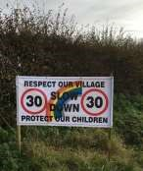
As reported in the December issue of the Messenger in November speed banners were erected on the 4 main entry roads in the Village. Following some vandalism more substantial posts were fitted but shortly afterwards 2 of the banners and their new posts disappeared from North Dalton Road and Beverley Road.
It beggars belief that someone would want to remove them and given the posts were securely affixed then some considerable effort had been made to remove them. Why? Who does not want to reduce speeding traffic passing through our village or to
keep our children safe as they try to cross our roads? Did you see anything or know anything about this theft? It may be that the culprit(s) may not be from the village ( a disgruntled motorist who may have been recently caught speeding?) but passing through but a thorough search of the fields and hedges around those roads have failed to unearth the banners or any clue as to what happened to them.
Following both weather damage and further suspected vandalism the banners at the top of Front Street and on the approach to Church Hill have been repaired and reinstated. No decision has yet been made as to whether to replace the missing banners as the Parish Council awaits the outcome of the traffic survey and hopes to meet soon to discuss this and other possible speed reduction ideas with East Riding of Yorkshire Council.
Nick Jones
nj@motwparishcouncil.co.uk
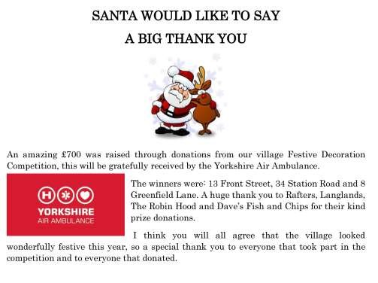

Just a few examples of the 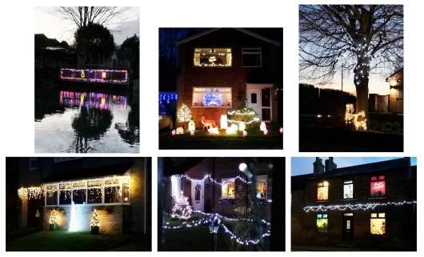fantastic lights

Middleton book group
December’s books:
To Everything a Season by Sherri Scaeffer tells the story of Taylor Loden, future heiress to her father’s media empire and work-acholic who is driving through Amish country and is in collision with a buggy driven by Jacob at speed through a red light. He is left in a paraplegic state and she feels she needs to help with his rehabilitation. Taylor also helps various other members of the family and the book is a study of the differences in their lifestyles. Although most enjoyed the book, we did find it a little far fetched at times.
The Paper Bracelet by Rachel English is about Katie, a young nurse in an Irish home for unmarried mothers run by nuns. In the year that she worked there she collected the babies’ identity bracelets and years later she decides to try to give some of those babies (now adults) links to their past. We found it to be a moving book and well worth a read.
Lyn

January’s books:
The Salt Path by Raynor Winn. True story of a middle-aged couple who have lost their family smallholding on top of which the husband has been diagnosed with a serious illness. As all their financial resources have been used to fight a lengthy court case they decide to walk the south west coastal path. With only the most rudimentary of equipment they are reliant on themselves, benefits and the kindness of strangers.
The Little Paris Bookshop by Nina George and Simon Parc. A story of love and loss set in Paris and the Occitane and regions in between. Jean-Luc runs a bookshop from his barge which is moored on the Seine where he matches books to his customers. The story centres on his search for Manon,his lost love,who left without a word leaving behind a letter which he has never felt able to open.
Lindsay

Next books for discussion:
“The Fourth Sacrifice” by Peter May
“White Teeth” by Zadie Smith (we have been warned about some bad language!)

To find out more about the Book Group please contact Lyn on 219500 or lyndennis456@gmail.com

ADVERTISING COSTS for the Messenger
Rates Month Year

Whole Page £25 £150

1/2 Page £15 £100

1/3 Page £10 £60
Full colour - Print run 500 copies
Contact: Tina 01377 217242, middletonflyer@yahoo.com
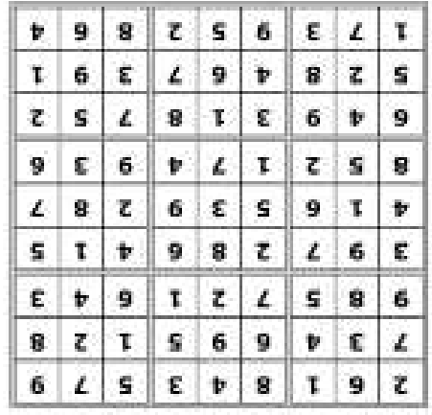
Quiz answers

Dingbats:

Down on one knee

Cupid

Mad for you

Sentiment

You are for me

Forever mine

Word wheel: Valentine
’
s Day

1

I am the Walrus

2

The King and I

3

1
st January,
1999.

4

Four

5

Violet

6

90
[January
24
th
1965]

7

Tiramisu

8

Skipping

9

Read Between The Lines

10

Feta

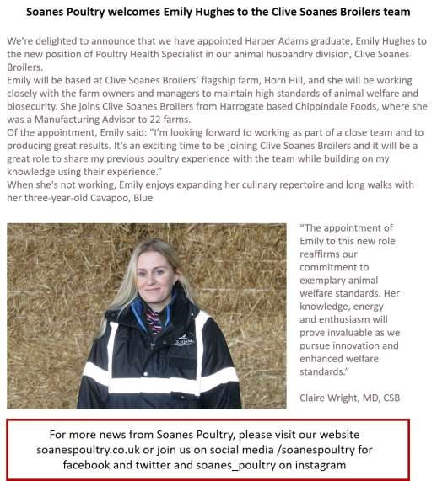
Advertising Feature

Advertisement
Advertising Feature
Regular group activities
Weekly Groups
Tuesday YCA 2.00-2.40pm Zoom
Thursday Middleton Movers 2.00-3.00pm Zoom

November
- Parish Council 7.00pm Zoom
- Village Hall Committee 2.30pm Zoom
7 Middleton Womblers 10.00am Lime View
(Please check)
12 Book Group 2.00pm Zoom
25 Yorkshire Countrywomen 7.00pm Zoom

LOCAL CONTACTS Bell Ringing Chris Atkin |  | 217285
Book Group/Middleton Movers | Lyn Dennis | 219500
Bowls Club | Rob Bradley | 217435
Country Women’s Association | Christine Johnson | 217374
First Responders | Chris Brent | 219469
Line Dancing | Pat Pottage | 217516
Methodist Chapel | Jane Gray | 07870 562455
Middleton Messenger | Mike Kelly | 07713 620912
 | Lyn Dennis | 219500
 | Tina Walker | 217242
Middleton Womblers | Andrew Naylor | 219072
Parish Clerk | Sandra Morrison | 01262 470496
Pilates | Ian Stephenson | 07973 755717
Reading Rooms | Kath Bentley | 217456
Recreation Club | Dave Newlove | 07901 833784
St Andrew’s Church | Rev Jane Anderson | 219471
St Andrew’s Church Warden | Roger Lowe | 217656
Table Tennis | Louise Newlove | 217801
Village Hall | Lyn Dennis | 219500
Village History | Geoff Wisher | 217517

